Suicide and Job Loss in a Cohort of Michigan Autoworkers

In some order: Eisen, Elser, Riddell, Chen, Goldman-Mellor, DuFault

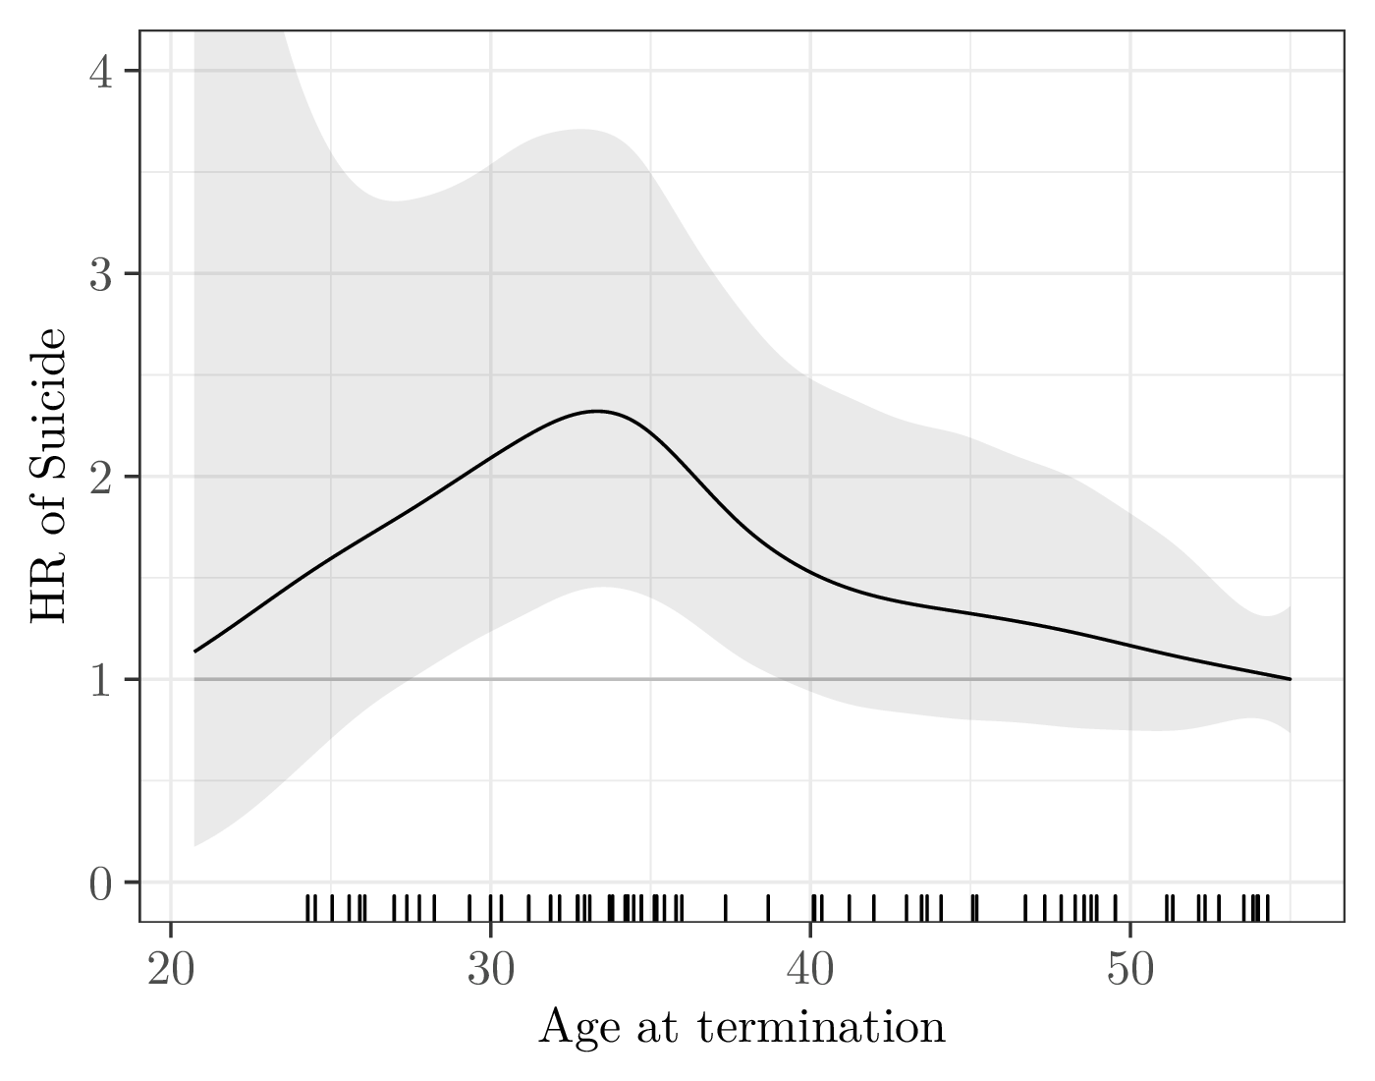Over the past 20 years, mortality rates for drug overdose and suicide have increased in the U.S. across all ages and ethnic groups, but most dramatically for working aged adults. Coincident with the increases in midlife mortality rates, decline in manufacturing has limited good employment options for many noncollege adults: 36% of all employed U.S. males worked in manufacturing in the 1970s – in 2018, only 15% did. In addition to employing a large proportion of the noncollege workforce, the sector is more spatially concentrated than others, potentially leading to long term economic distress for those who lose these jobs. There is recent evidence supporting the hypothesis that eroding economic opportunity may explain some of the recent increase in mortality due to suicide and overdose. We take advantage of individual-level data collected on a cohort of unionized Michigan autoworkers to examine the association between job termination and risk of suicide and overdose mortality. All subjects worked at least 3 years in one of 3 Michigan plants and were hired prior to 1982. By restricting start of follow-up to 1970, we assume that all job termination under the age of 55 was involuntary. Follow-up for each subject begins at leaving work and extends to 2015. Focusing on the subset of 26,890 still employed or not yet hired in 1970, there were 213 deaths due to suicide (n = 179) or overdose (n = 34). Restricting the analysis to males (only 12 female cases), we estimated hazard ratios (HRs) for suicide and age at leaving work. We defined retirement as age 55 or older and treated leaving work after age 55 as the reference. Cox models were adjusted for plant (1,2,or 3), race (Black or White), calendar year of leaving work, age at hire, and time since leaving work. Restricting follow-up to 5 years after leaving work, the adjusted HRs were 1.37 (95%CI: 0.76, 2.46), 1.90 (1.00, 3.61), and 1.62 (0.69, 3.83) for leaving work between ages 40-54, 30-39, and ≤ 29. HRs from a Cox model with a spline function of age at leaving work ( $df$ = 4) is presented in the Figure. Results support the hypothesis that since 1970, autoworkers who left good union jobs prior to retirement had elevated risk of suicide or overdose within 5 years of leaving work.